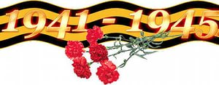
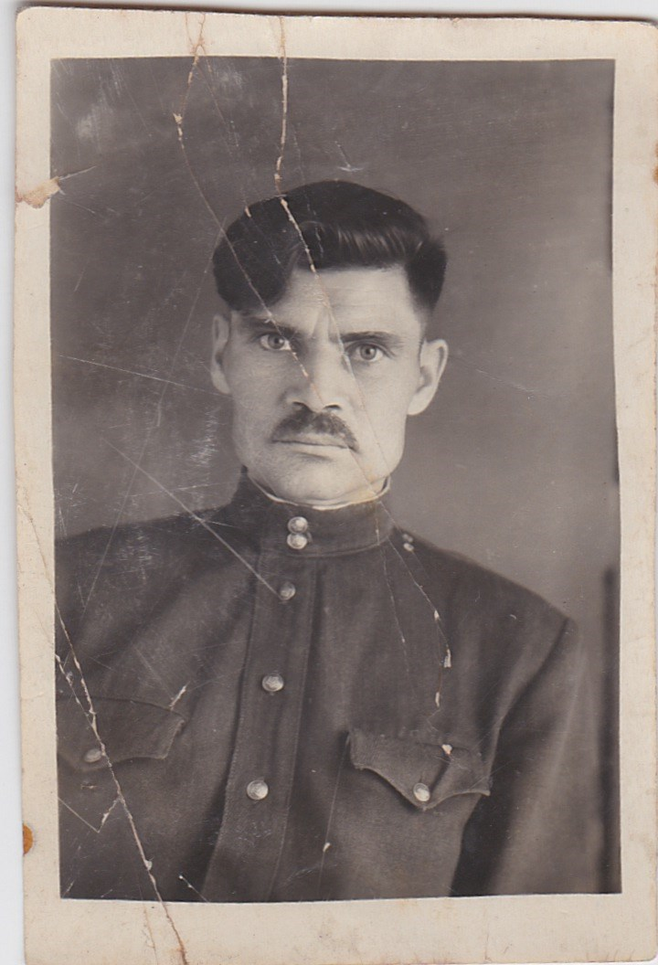
Hello! My name is Tanya Shalkova. I am 9 years old. I would like to tell you about my great grandfather. His name was Grigory Kamzarakov. He was born on the 24th of April in 1919 year in Tashtagol district. He had blue eyes and black curly hair.
In February, 1940 my great grandfather was called for service in the Soviet army. He served in the army near Moscow. From June 1941 he was on the frontline as a сommunicator. He pulled the communication line under the bombing and shelling, took part in the battles the Great Patriotic War, defended our Motherland from the Nazis. My great grandfather was not injured. This war took the lives of millions Soviet people.
In May, 1945 my great grandfather was in Berlin when the war ended with the great victory of our people. It was the happiest day in the life of my country. My great grandfather awarded the order of the Red Star, medals "For bravery", "For defense of Moscow", "For Victory over Germany" and other. He came back from the war in 1947 because he served in the Soviet army in Estonia also two years. Later he settled in Tashtagol (Mountain Shoria), married and in 1957 was born my grandfather Vladislav Kamzarakov. He worked as a fireman at the mine "Tashtagol", but his great love was art. He was an amateur artist. Several of his drawings and one self-portrait presented in this work. My great grandfather did not like to remember and tell about the war.
In Russia Victory Day, or 9th May, is one of the great holidays of the year. It is holiday of all my family.
This year marks the 70th anniversary of Russia's victory in the Great Patriotic War. In the January this year was born my brother – Grigory. His was called Gregory in honor of our great grandfather.
Grigory Kamzarakov died in 1979 when he was 60 years old. Veterans of that terrible war are becoming less and less. I think we should help them to live in dignity and respect their age and merits before our Motherland.
